Migration drools 5.x to 6.2

1. Prepare Migration Tool

- Download the “kie-drools-wb-distribution-6.2.0.Final” from drools website. in folder “kie-drools-wb-distribution-6.2.0.Final\migration”, There is zip file “drools-wb-jcr2vfs-distribution-6.2.0.Final.zip”.

- Create a new folder “drools”(at here,I create it on F disk “F:/drools”. Unzip this file “drools-wb-jcr2vfs-distribution-6.2.0.Final.zip” to folder “F:/drools”.

2. Find old Repository from drools 5.x

- The Repository is stored in a default tomcat bin folder. see “Pic 1”.

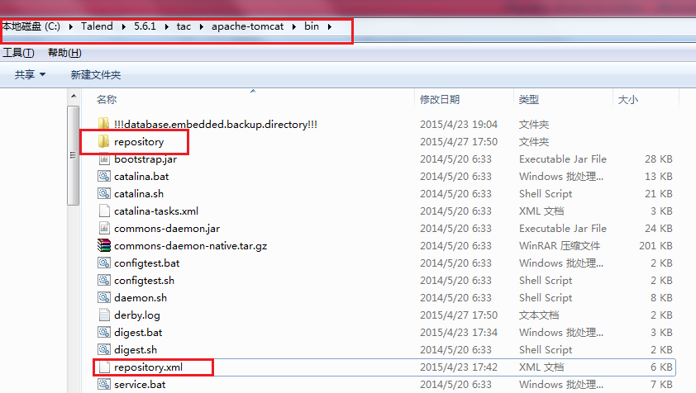

Pic 1

* Copy folder “Repository” and “Repository.xml” to a folder(f:/drools/inputSrc),we look it as a input resource for this Migration Tool.

1. Migrate JCR to VFS by “runMigration.bat”

* Open a command line window
* Command1: Cd F:\drools\drools-wb-jcr2vfs-distribution-6.2.0.Final\bin
* Command2: runMigration.bat –i F:/drools/input. See “Pic 2”.

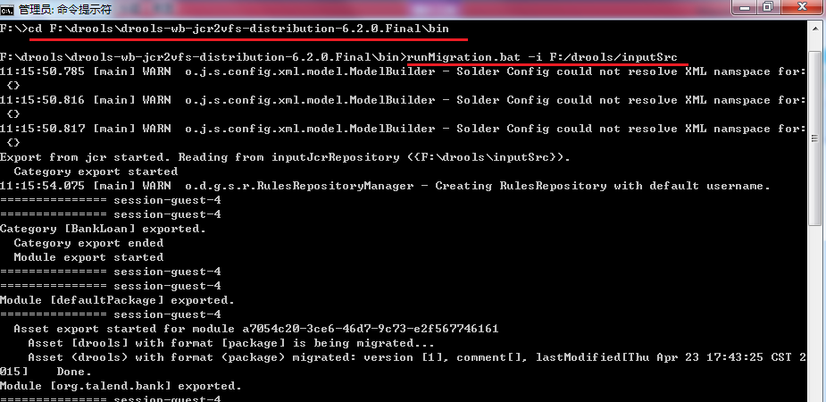

Pic 2

There is a warning in the cmd window: ” WARNING: POJO Model jar [BankLoanModel] is not supported by export tool. Please add your POJO model jar to Gu

vnor manually.”

We don’t care it at here, we will upload the jar to doorls 6 later .

* After running this bat file, you can see several folders are automatically generated in folder “bin”.:” .niogit”,” outputVfs”,” tmp-jcr2vfs”,” derby.log”,” runMigration.log”.
* Open folder “outputVfs”, there is a folder “ guvnor-jcr2vfs-migration.git”.it is a migrated folder.

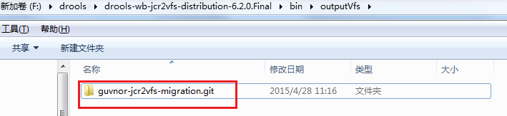

Pic 3

**So far, the JCR is migrated VFS by the Tool.**

1. Import the VFS to drools 6.2

* start the TAC server ;
* login on TAC in Web Browser;
* open drools page, clone the repository which is from migrated VFS in step 3.

See Pic 4,Pci 5.Pic 5, Pic 6

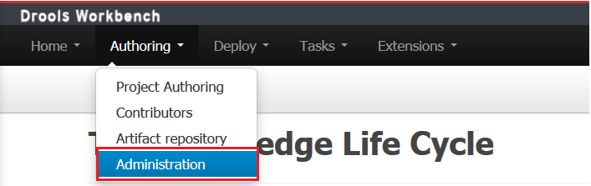

Pic 4

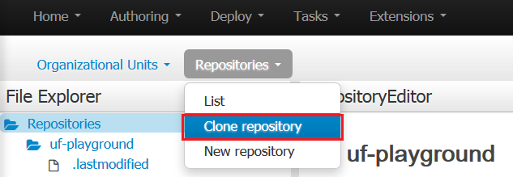

Pic 5

* Input a Repository Name as you want.
* Select a Organizational Unite. Here I just select the default “demo”. You also create a new Organizational Unite before this selection.
* Git URL is located the “outputVfs” which is generated in step 3.The value is like :

file:///F:/drools/drools-wb-jcr2vfs-distribution-6.2.0.Final/bin/outputVfs/guvnor-jcr2vfs-migration.git

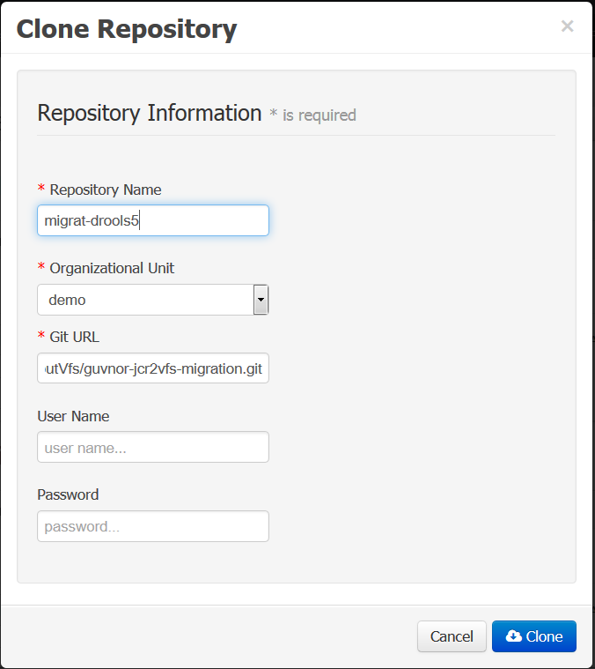

Pic 6

* Clone repository will be successful. We can see it in Pic 7

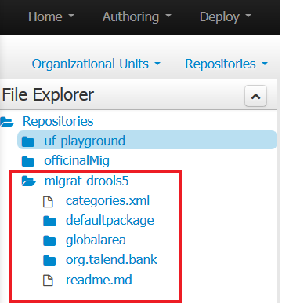

Pic 7

1. Upload POJO Model jar

when I open the rule editor, it has some errors, because the POJO Model Jar is not imported in step 3. It had a warning in step 3. Let’s upload the jar to drools 6 manually.

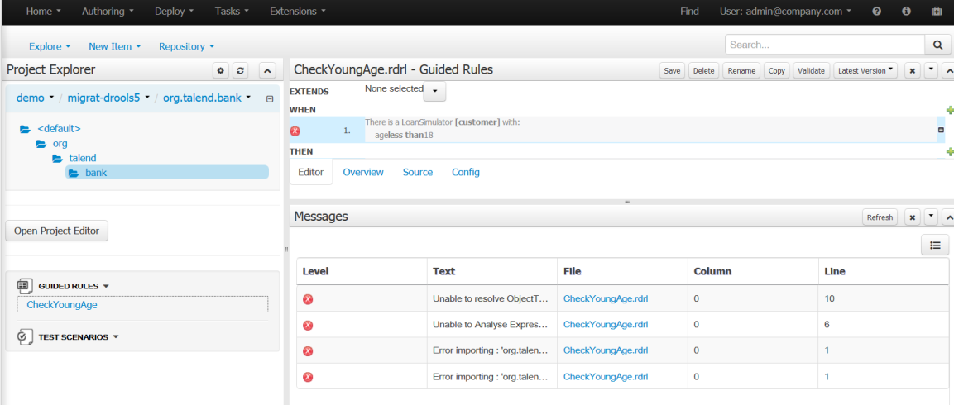

Pic 8

* Menu: “Authoring-🡪Artifact Repository”. It will open page like “Pic 9”.
* Click “Upload”,it will pop a dialog to select POJO jar.

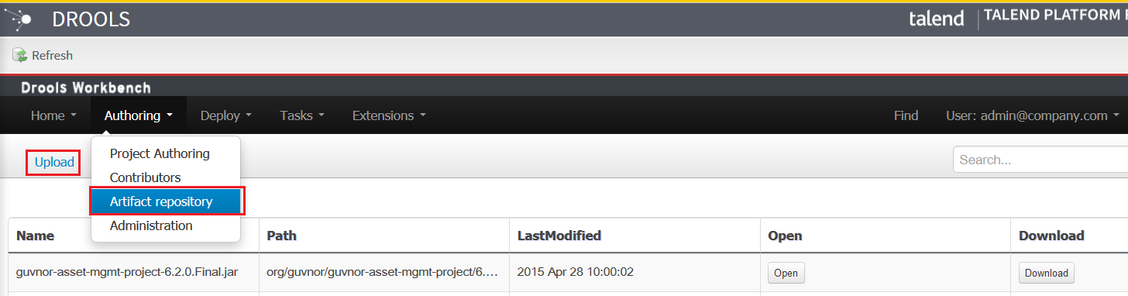

Pic 9

* Select the POJO Model jar “LoanModel.jar”. This jar is same as in drools 5 POJO Model jar.
* Click “Upload ” button in this dialog(“Pic 10-1”).

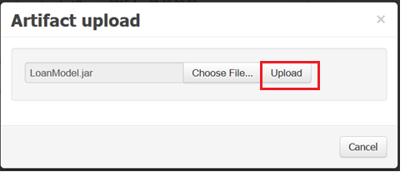

Pic 10-1

* It will pop a dialog (Pic 10-2),click “OK”.

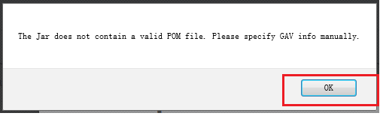

Pic 10-2

* it will pop a dialog(Pic 11). Fill the information in “Pic 11”.then click “upload”. It will be uploaded successfully.

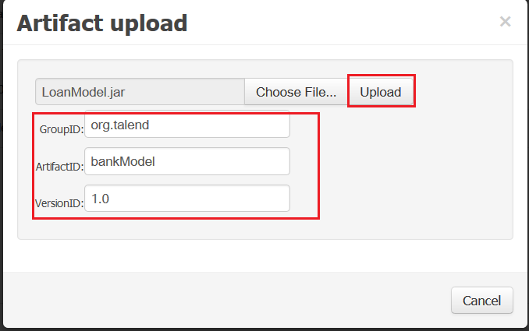

Pic 11

* we can see the bank.jar is uploaded (Pic 12)

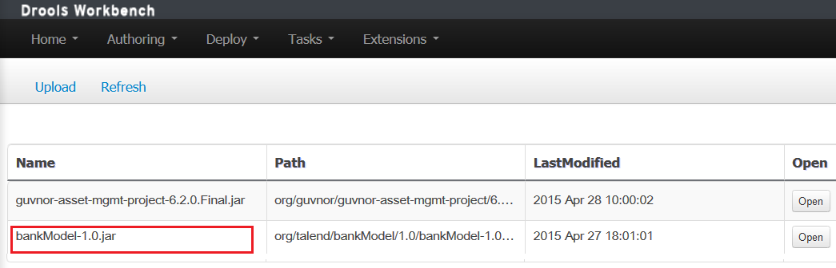

Pic 12

1. Add the uploaded jar as a dependency for the migrated Repository “migrate-drools5”.

* Authoring->Project, select project “org.talend.bank” in Repository “migrate-drools5”.
* Click “Open Project Editor”. See “Pic 13”

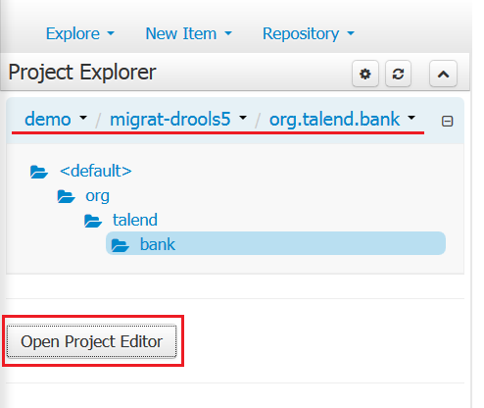

Pic 13

* In the Repository editor, Click “Project Settings:Project General Settings”. Select “Dependecies”. See “Pic 14”.

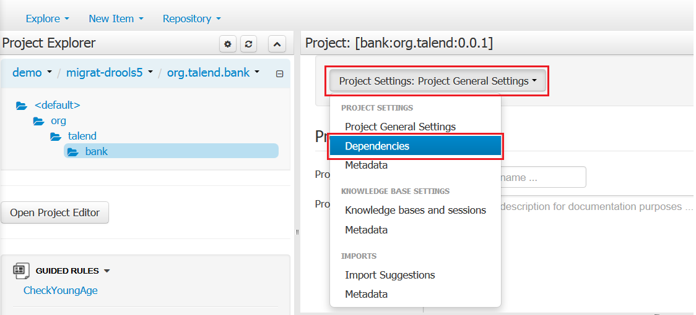

Pic 14

* Click button “Add from repository”.

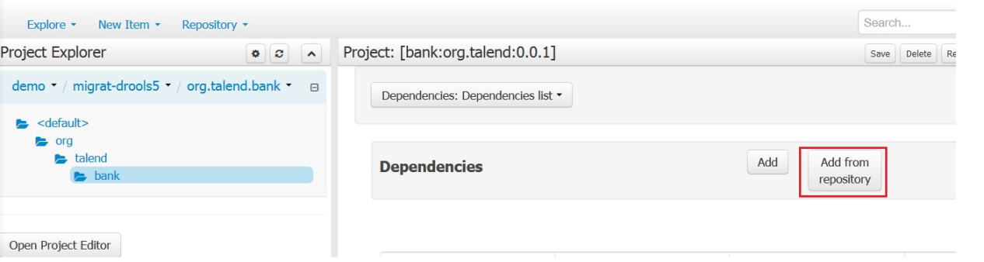

Pic 15

* It will open a dialog with all jars, click “select” button on the line of “bankModel-1.0.jar”. See “Pic 16”.

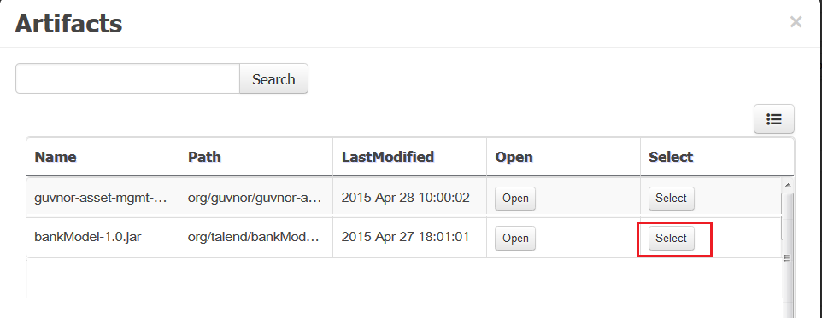

Pic 16

* Save the Repository Editor.

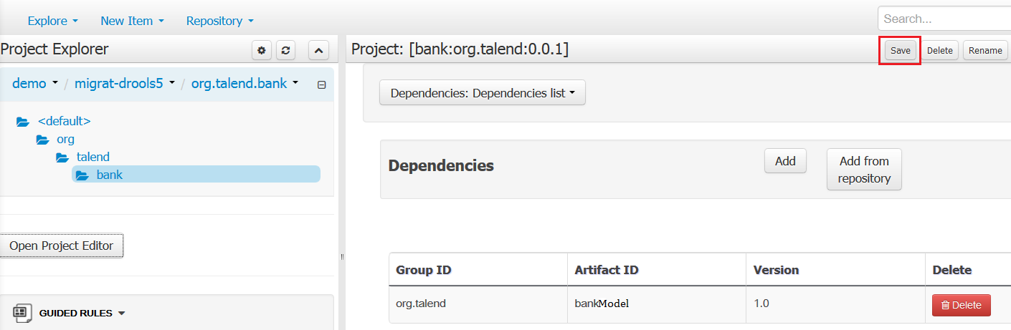

Pic 17

1. Run the Test Scenarios

* After uploading POJO and setting dependencies, we can open the rule(“CheckYourAge”) without any errors.
* We also can run the Test Scenarios.

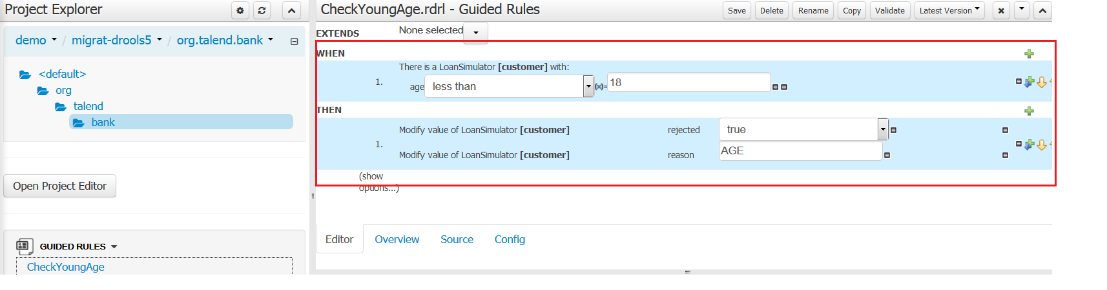

Pic 18

1. Build the project

* “Open Project Editor”, click button “build ”.

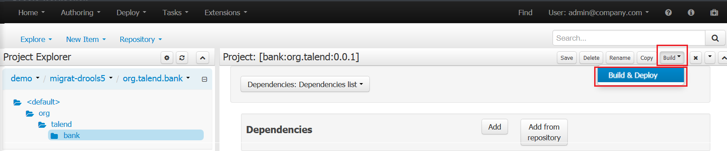

Pic 19

* It will be successfully, we can see it by click menu “Authoring->Artifact Repository”.

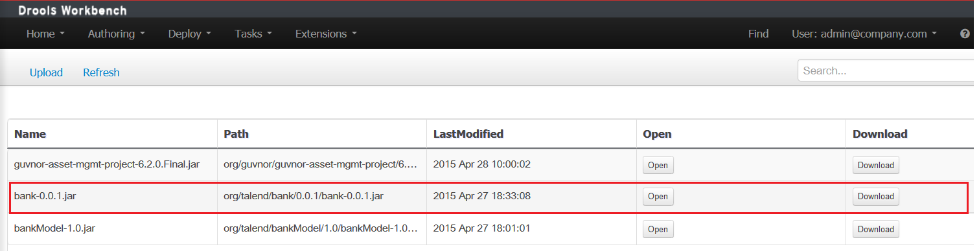

Pic 20

1. Run job with tBRMS component on Talend studio.

* Import the old job with component tBRMS.
* Configure the attribute on component UI. The old configuration is like “Pic 21”.

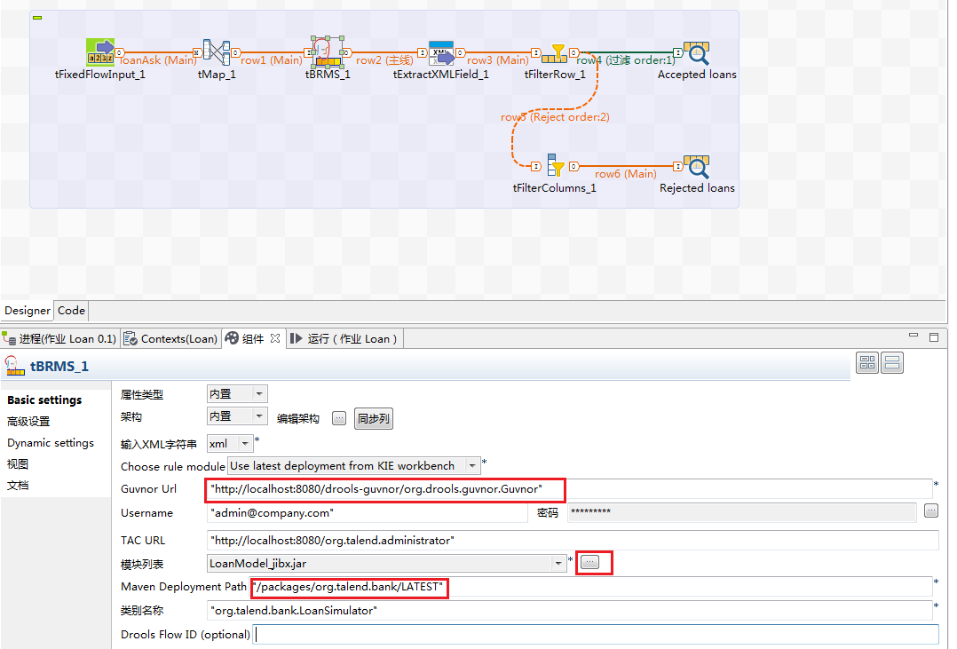

Pic 21 (old configuration)

We need to change these 3 attribute. Please see “Pic 22” “Pic 23”.

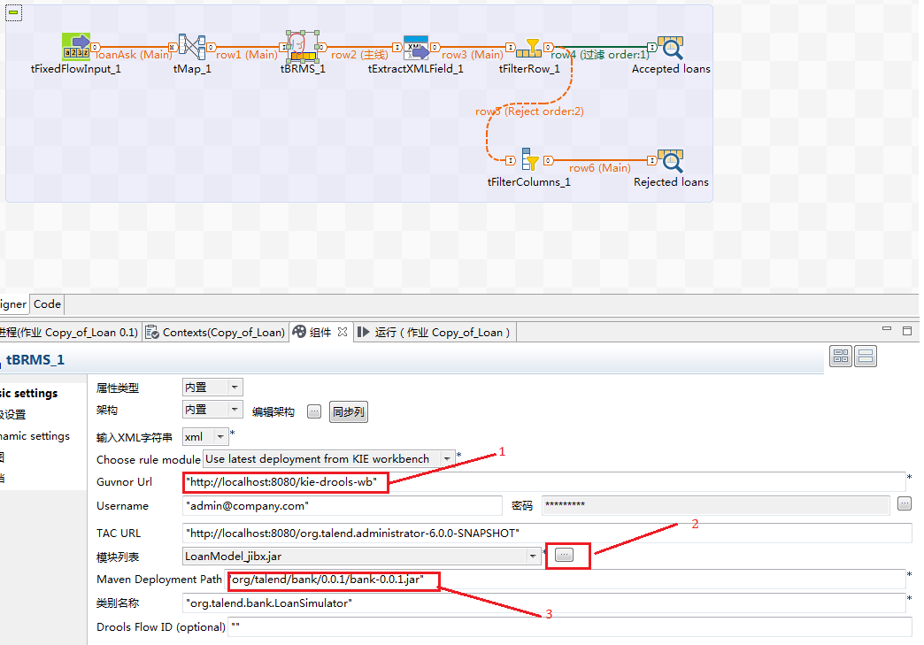

Pic 22 (new configuration)

About the mark “2” in Pic 22,click this button ,it will open a dialog as “Pic 23”. Do the steps like “Pic 23”.but there is a bug now( <https://jira.talendforge.org/browse/TDQ-10258> ),after this bug fixed, we can use this wizard to get a related “LoanModel_jibx.jar”. There is a workaround an no need to do steps mark “2” and “Pic 23”: copy the “LoanModel_jibx.jar” from old workspace(Talend 5.6.1 or lower version) to Talend 6.0 workspace lib folder(like as “Talend-Studio-20150408_1742-V6.0.0M4\configuration\lib\java”).

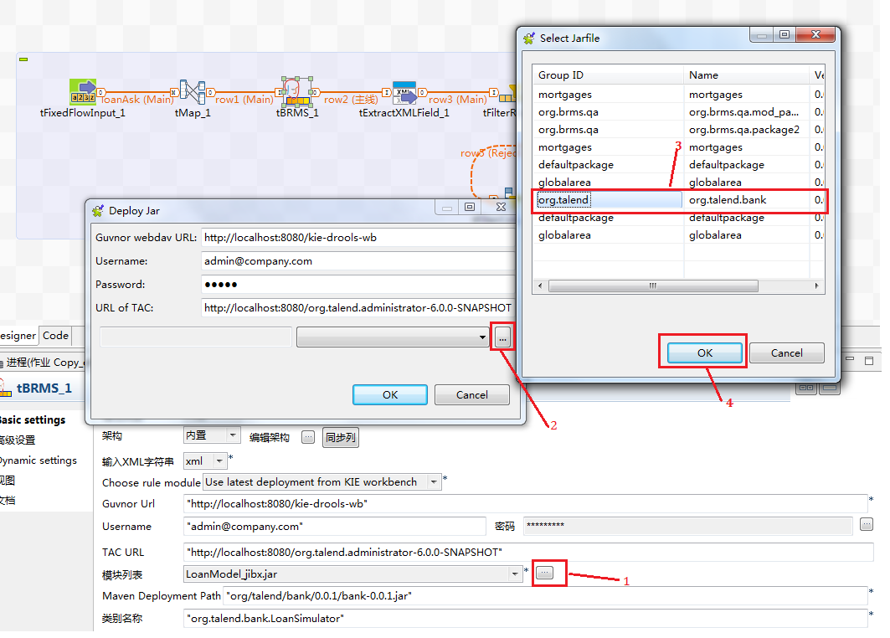

Pic 23

* Run this job, it will works.